# Homework Assignment (Problem Set) 2:

Note, Problem Set 2 directly focuses on Modules 3 and 4: Linear Programming and the Economic Interpretation of the Dual and Sensitivity Analysis, and Network Models.

**Jamia Russell**

***5 questions***

**Rubric:**

All questions worth 30 points

30 Points: Answer and solution are fully correct and detailed professionally.

26-29 Points: Answer and solution are deficient in some manner but mostly correct.

21-25 Points: Answer and solution are missing a key element or two.

1-20 Points: Answer and solution are missing multiple elements are significantly deficient/incomprehensible.

0 Points: No answer provided.

Question 1:

**1A.** Write the general dual problem associated with the given LP.

*(Do not transform or rewrite the primal problem before writing the general dual)*

Maximize –4x1 + 2x2

Subject To

4x1 + x2 + x3 ≥ 20

2x1 – x2 ≤ 6

x1 – x2 + 5x3 = –5

–3x1 + 2x2 + x3 ≥ 4

x1 ≥ 0, x2 ≤ 0, x3 unrestricted

**Answer:**

**Dual:**

20y1+6y2-5y3+4y4

4y1+2y2+y3+2y4  ≤ -4

Y1-y2-y3+2y4≤ 2

Y1+5y3+y4  = 0

Y3 unrestricted

Y2, ≤ 0

Y1,Y4 ≥ 0

**1B.** Given the following information for a product-mix problem with three products and three resources.

**Primal Decision Variables:** x1 = number of unit 1 produced; x2 = # of unit 2 produced; x3 = # of unit 3 produced

**Primal Formulation: Dual Formulation:**

Max Z (Rev.) = 25x1 + 30x2 + 20x3 Min W = 50π1 + 20π2 +25π3

Subject To 8x1 + 6x2 + x3 ≤ 50 (Res. 1 constraint) Subject To 8π1 + 4π2 +2π3≥ 25

4x1 + 2x2 + 3x3 ≤ 20 (Res. 2 constraint) 6π1 + 2π2 +π3 ≥ 30  
 2x1 + x2 + 2x3 ≤ 25 (Res. 3 constraint) π1 + 3π2 +2π3≥ 20

x1, x2, x3 ≥ 0 (Nonnegativity) π1, π2, π3 ≥ 0

**Optimal Solution:**

Optimal Z = Revenue = $268.75

x1 = 0 (Number of unit 1) Dual Var. Optimal Value = 22.5 (Surplus variable in 1st dual constraint)

x2 = 8.125 (Number of unit 2) Dual Var. Optimal Value = 0 (Surplus variable in 2nd dual constraint)

x3 = 1.25 (Number of unit 3) Dual Var. Optimal Value = 0 (Surplus variable in 3rd dual constraint)

Resource Constraints:

Resource 1 = 0 leftover units Dual Var. Optimal Value = 3.125 = π1

Resource 2 = 0 leftover units Dual Var. Optimal Value = 5.625 = π2

Resource 3 = 14.375 leftover units Dual Var. Optimal Value = 0 = π3

***1Bi.*** What is the fair-market price for one unit of Resource 3?

**Answer:** Fair market price for one unit of resource 3 is $0/unit.

***1Bii.*** What is the meaning of the surplus variable value of 22.5 in the 1st dual constraint with respect to the primal problem?

**Answer:** The surplus variable value of 22.5 shows that an additional unit of Resource 1 can achieve a revenue increase if other constraints are unchanged.

Question 2:

Seat and Greet manufactures couches and love seats. Each couch contributes $850 to profit and each love seat, $650. The resource requirements (square feet of fabric, cubic feet of stuffing, and number or workers to complete an item in one day) and availability are shown in the table below. Marketing considerations dictate that at least 50 couches and at least 40 love seats be produced.



Part A: Formulate the problem as a Linear Program.

**Answer:**

Obj: 850x1+650x2 x1 : couch, x2:love seat

Contraints:

40x1+25x2​≤3500

120x1+70x2​≤ 9010

3x1+2x2 ≤ 250

x​1≥50

x2≥40

x1,x2≥0

Part B: Solve the LP (provide exact values for all variables and the optimal objective function).

*Hint: The optimal objective function value is $70,450*

*[Note, I am providing this hint because having the optimal solution is necessary to do Part C.]*

**Answer: \***attached*

Part C: Answer the following questions from your output. *(Note, do not simply rerun the model – use the Linear Programming output and Sensitivity Analysis to explain your answers.)*

i) If couches contributed $1,000 to profit, what would be the new optimal solution to the problem (decision variables and objective function)?

**Answer:** If couches were to contribute $1,000 to profit thus changing the objective co-efficient to $1,000 there would be a change in the optimal solution, but constraints will not be violated being that the increase is within the acceptable range of +Inf. Limit of 52 that wouldn’t be profitable.

Obj Function: 1000x1+650x2

Increase in obj coefficient is: $150

Change in objective value: $7,500

New obj value: $70,450+$7,500 = $77,950

Decision Variables: Couches (50), Love Seat (43)

ii) What is the most that Seat and Greet should be willing to pay for an extra cubic foot of stuffing?

**Answer:** Seat and Greet should not pay for any additional stuffing.

iii) If Seat and Greet were required to produce at least 45 couches, what would their profit be?

**Answer:**  Seat and Greet already has an optimal solution that includes the production of 45 couches. However, if we were to change the production bounds to at least 45 couches, profit would be $71,771.43

iv) Seat and Greet is considering producing reclining chairs. A reclining chair contributes $500 to profit and requires 30 square feet of fabric, 15 cubic feet of stuffing, and 2 workers to produce a chair in one day. Should Seat and Greet produce any reclining chairs? **Again,** **do not rerun the model.**

**Answer:**

New obj function: 850x1+650x2+500x3

Contraints:

40x1+25x2​+30x3≤3500

120x1+70x2+15x3​≤ 9010

3x1+2x2+2x3≤ 250

x​1≥50

yx2≥40

x1,x2,x3≥0

The new variable will cause an increase in profit from $70,450 to $74,493 from 8 reclining chairs. Yes, Seat and Greet should produce reclining chairs.

Question 3:

Suppose you are in the market to buy a new car for $20,000. The total maintenance costs for this car are dependent on its age in years (see table below). So the total maintenance of a car after 3 years is $7,000, not ($3,000 + $5,000 + $7,000 = $15,000). However, you can avoid growing maintenance costs by trading in the car at any point, the value of which is also dependent on its age in years (see same table below). Suppose that if you trade a car in at any point in the next 5 years, the cost of the new car you purchase is still $20,000. You hope to minimize the net cost of having a car over the next five years (purchase costs + maintenance costs – trade-in value).



Part A: Formulate this as a shortest-path network problem and draw the network.

As a hint, think about the cost associated with having the car from year 1 to year 2 (or for 1 year total) - $20,000 + $3,000 - $12,000 = $11,000. What is it from year 1 to year 3 (or for 2 years total)? $20,000 + $5,000 - $10,000 = $15,000. Remember that these are the costs for a specific period of time, and that year 1 to year 3 is equivalent to year 2 to year 4. So you need to include the cost for every period of time between years 1 and 6.

**Answer:** xij = 0 or 1 (binary)

x01​+x02​+x03​+x04​+x05​=1 start xij: Binary variable if the car is kept from year i to year j

x01​−x12​−x13​−x14​−x15​=0 y1

x02​+x12​−x23​−x24​−x25​=0 y2

x03​+x13​+x23​−x34​−x35​=0 y3

x04​+x14​+x24​+x34​−x45​=0 y4

x05​+x15​+x25​+x35​+x45​=1 end

Part B: Solve the problem and give the best plan (shortest path) to have a car for the next 5 years at the lowest cost.

**Answer: *attached\***

Question 4:

An average of 900 cars enter a traffic network (shown below) each hour, trying to make it from node 1 to node 9. The maximum number of cars that can pass over each arc and the time it takes a car to drive each arc is shown below. Use a minimum cost network flow model to minimize the total time for the 900 cars to drive from node 1 to node 9 (assuming all enter at the same time and traffic jams do not exist).

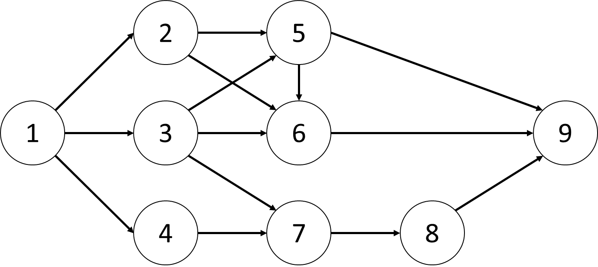 

Part A: Formulate the problem as a minimum cost network flow problem

**Answer:**

Maximize Z = 16*x12 + 30*x13 + 7*x14 + 17*x25 + 12*x26 + 1*x35 + 4*x36 + 18*x37 + 20*x47 + 13*x56 + 5*x59 + 5*x69 + 2*x78 + 7*x89

xij : cars from node 1 to node j

tij: travel time

x12<= 500 x35<= 400 xij >= 0

x36<= 300 x47 <=400

x37<= 250 x56 <=200

x47<= 500 x59 <=600

x13<= 500 x60 <=900

x14<= 400 x78 <=700

x25<= 350 x89 <=700

x26<= 350

t12 = 16 t13=30

t14=7 t25=7

t26=12 t35=1

t36=4 t37=18

t47=20 t56=5

t69=5 t78=2

t89=7

Part B: Solve the problem and provide the solution (decision variables and objective function).

**Answer: *attached\***

Question 5:

A university has three professors who each teach four courses per year. Each year, four sections of marketing, finance, and production must be offered. At least one section of each class must be offered during each semester (fall and spring). Each professor’s time preferences and preference for teaching various courses are given below.

The total satisfaction a professor earns teaching a class is the sum of the semester satisfaction and the course satisfaction. Thus, professor 1 derives a satisfaction of 3 + 3 = 6 from teaching marketing during the fall semester.



Part A: Formulate the problem as a minimum cost network flow problem that can be used to assign professors to courses to maximize the total satisfaction of the three professors. Draw the network and identify the nodes and arcs.

**Answer:**

Maximize Z=6x11F​+10x11S​+8x12F​+7x12S​+11x13F​+9x13S​+10x21F​+9x21S​+12x22F​+8x22S​+7x23F​+10x23S​+9x31F​+11x31S​+10x32F​+10x32S​+12x33F​+11x33S​

Constraints:

x11F​: Professor 1 teaching Marketing in the Fall term.

x11S​: Professor 1 teaching Marketing in the Spring term.

x12F​: Professor 1 teaching Finance in the Fall term.

x12S​​: Professor 1 teaching Finance in the Spring term.

x13F​: Professor 1 teaching Production in the Fall term.

x13S​​: Professor 1 teaching Production in the Spring term.

Etc for prof 2 and 3 for each term

x11F​+x11S​+x12F​+x12S​+x13F​+x13S​=4

x21F​+x21S​+x22F​+x22S​+x23F​+x23S​=4

x31F​+x31S​+x32F​+x32S​+x33F​+x33S​=4

x11F​+x21F​+x31F​+x11S​+x21S​+x31S​=4

x12F​+x22F​+x32F​+x12S​+x22S​+x32S​=4

x13F​+x23F​+x33F​+x13S​+x23S​+x33S​=4

x11F​+x21F​+x31F​=1

x11S​+x21S​+x31S​=1

x12F​+x22F​+x32F​=1

x12S​+x22S​+x32S​=1

x13F​+x23F​+x33F​=1

x13S​+x23S​+x33S​=1

x11F​+x21F​+x31F​≥1

x11S​+x21S​+x31S​≥1

x12F​+x22F​+x32F​≥1

x12S​+x22S​+x32S​≥1

x13F​+x23F​+x33F​≥1

x13S​+x23S​+x33S​≥1

Part B: Solve the problem (provide exact values for all variables and the optimal objective function).

**Answer: *attached\***